Medicinal Product Shortages

A framework for a multi-stakeholder approach to handling shortages of human medicinal products

**Supported by:**



CONTENTS

GLossary of Terms 3

1 Purpose 4

2 Definition 4

3 Role of Stakeholders 6

4 Principles of the framework 9

5 Medicine shortages framework 9

6 Preventative Strategies 13

7 Concluding remarks 14

GLossary of Terms

|  |  |
| --- | --- |
| Healthcare professionals | Healthcare professionals are stakeholders that include prescribers, pharmacists and nurses. |
| Impact assessment | An impact assessment is performed in order to determine the impact of a potential or actual shortage on patients. |
| Manufacturer | The manufacturer is a stakeholder that has been authorised to produce medicinal products. The manufacturer may or may not also be the marketing authorisation holder (MAH). |
| Marketing authorisation holder (MAH) | The MAH is the stakeholder in whose name the marketing authorisation for a medicinal product has been granted. The MAH is responsible for all aspects of the medicinal product, including quality and compliance with the conditions of the marketing authorisation. |
| Marketing authorisation number | Each authorised medicinal product has a specific reference number associated with it and that is detailed on the product packaging. The marketing authorisation number usually take the form of a sequence of letters followed by numbers. The letters can be PA, PPA, DPR or EU for example. |
| Medicinal product shortage | A medicinal product shortage occurs where the supply of a medicinal product is inadequate to meet the needs of patients. |
| Notification | A notification is a communication of a shortage from a marketing authorisation holder (MAH). |
| Report | A report is a communication of a shortage from any stakeholder that is not a marketing authorisation holder (or their representative). This includes a manufacturer, wholesale distributor, healthcare professional or patient. |
| Wholesale distributor | The wholesale distributor is a stakeholder that has been authorised to distribute medicinal products. |

1. Purpose

Medicine shortages are recognised as a global problem by the World Health Organization. Whilst medicine shortages have been a global issue for some time, they have increasingly affected Ireland and other European countries with significant impact on patient care and total healthcare costs.

The purpose of this document is to outline a framework for the Health Products Regulatory Authority (HPRA) and other stakeholders to address the issue of medicine shortages in Ireland.

The aim of the framework is to help avert potential shortages from occurring and to reduce the impact of shortages on patientsby co-ordinating the management of potential or actual shortages as they arise. This document focusses primarily on the approach to managing potential or actual shortages through enhancing procedures for notification of shortages, their evaluation and outward communication. Whilst preventative strategies are briefly indicated in Section 6, the detail is not described in this document. The development of the framework will be an iterative process and these areas will follow. The framework does not cover commercial activities such as pricing of medicines, sourcing of medicines from suppliers and the clinical specifics of patient treatment in the event of a shortage.

The framework was generated following a review of current practices in Ireland and other countries, other published frameworks for the management of medicine shortages and consultation with representatives of healthcare professionals, patients, industry, state agencies and academics.

1. Definition

Causes of medicine shortages are multifactorial and involve multiple stakeholders. The Irish response to medicine shortages, therefore, is based on a multi-stakeholder approach, where collaboration with stakeholders is the foundation of an informed and practical response. Communication of critical information amongst stakeholders is central to this.

Developing long-term strategies focused on the underlying causes of shortages can reduce the likelihood of shortages occurring. The HPRA will work with stakeholders to implement long-term strategies to prevent shortages, which will take into account strategies proposed by stakeholders.

In order to provide clarity within the Irish context, the definition of a shortage is when:

***the supply of a medicinal product is inadequate to meet the needs of patients***

The definition makes patients the central focus of the impact of shortages. The definition also takes into account a number of important factors such as:

* **All medicines are included within the scope of the definition** (i.e. prescription and non-prescription medicines).
* **There is a supply and demand perspective**; where there is no demand for a medicine to treat patients, a shortage of this product does not have significance for patients.
* **The definition is applied at an individual product level**; this means that a specific medicine could be defined as being in short supply even if there are equivalent alternatives available.

Patient impact and the potential critical nature of a shortage are important components in determining the response to a shortage. These concepts are complex and have been built into the assessment component, where multiple factors are considered, on a case-by-case basis (see section 5.2).

Examples of what may not be considered as medicine shortages are highlighted in the box below.

* Where a medicine is **not yet authorised** or which is authorised and not marketed in Ireland for commercial reasons.
* A delay in supply of a medicine to a pharmacy due to **logistic reasons** or an error in delivery would not be considered as a medicine shortage as it is, in essence, a logistics issue and the medicine is generally available.
* Where normal supply to a wholesale distributor has been delayed, but there is **sufficient stock at wholesale level** that normal supply to patients will not be impacted.
* Where **only one wholesaler** is not in a situation to supply the particular medicine and others can supply the medicine.

Exempt medicinal products (EMPs) are part of mainstay treatment of some conditions. Where this is the case and a shortage occurs with these EMPs, the framework will be applicable.

The definition of a shortage also allows stakeholders to identify a potential shortage situation. Not all potential shortages will result in actual shortages. One key aspect in the mitigation of a possible shortage is early notification to the HPRA. The earlier the notification of a potential or actual shortage, the more time there is to possibly prevent it occurring or greatly reduce its impact by allowing stakeholders to find alternative solutions.

1. Role of Stakeholders

All stakeholders involved in the medicine supply chain have a role in ensuring access to medicines. As a consequence, all stakeholders in the supply chain have important roles in the prevention and management of shortages. The sections below outline the roles of different stakeholder groups in the management of shortages.

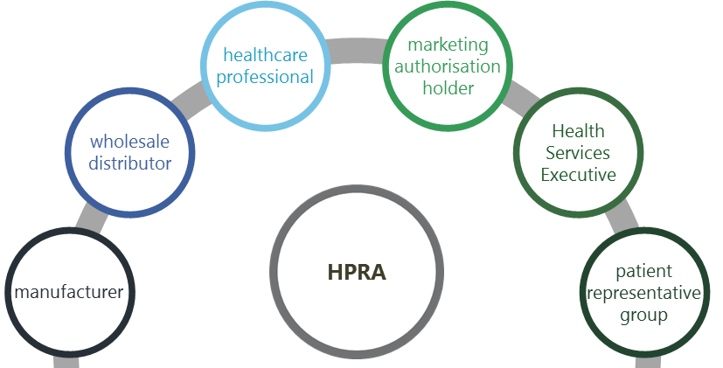

**Figure 1:** Multi-stakeholder involvement

* 1. Marketing authorisation holders

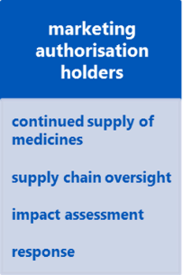Marketing authorisation holders (MAHs) are legally obliged, within the limits of their responsibilities, to ensure appropriate and continued supplies to meet the needs of patients in the State. They have oversight of the supply of their medicines nationally and globally. They can therefore continually align demand with supply as well as understand the impact of a given shortage on patients and prepare an appropriate response. MAHs also develop strategies to prevent shortages from occurring.

Where an actual or potential shortage occurs, MAHs assess the circumstances, perform an impact assessment to determine the potential impact of the shortage on patients and notify the HPRA. MAHs also propose a proportionate response to reduce the impact on patients.

* 1. Manufacturers

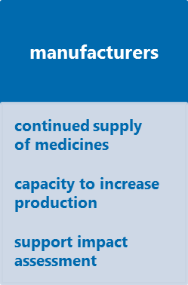Manufacturers also have a legal obligation, within the limits of their responsibility, to ensure appropriate and continued supplies of products manufactured by them so that the needs of patients are met. Capacity to manage reasonable demand fluctuations should be built into operating and planning procedures to allow adjustments to be made to supply to the market thereby preventing a shortage. Manufacturers also implement risk-based strategies to preventing shortages due to the manufacturing process.

Manufacturers also identify manufacturing issues that are general in nature and not specific to any product but which could result in potential or actual shortages. This is particularly important where a single manufacturer is contracted to produce medicinal products for a number of MAHs. The impact of a manufacturing issue in this case could extend beyond one product. The manufacturer should report these issues to the HPRA independently of the MAHs.

* 1. Wholesale distributors

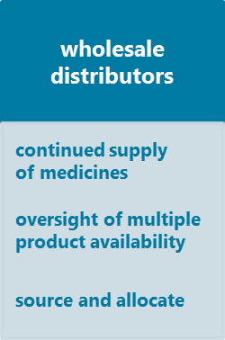Wholesale distributors have a legal obligation to ensure, within the limits of their responsibility, appropriate and continued supplies of medicines so that the needs of patients are met. Wholesale distributors act as the interface between the MAH or manufacturer and persons entitled to supply medicines to the public; they may be well-placed to identify signals of a medicine shortage.

During a medicine shortage, wholesale distributors are in a position to source medicines, monitor and communicate stock levels, and manage equitable distribution to hospital and community pharmacies through the proportional allocation of remaining stocks. In many cases, the wholesaler is in a position to supply an alternative treatment to the healthcare professional. Wholesale distributors can also report to the HPRA any general issues that could result in potential or actual shortages of medicines, independently of the MAH.

* 1. Health Services Executive

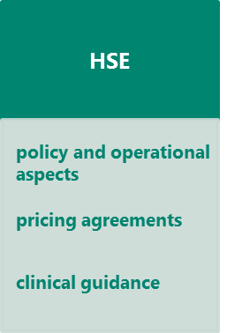The Health Service Executive (HSE) is responsible for policy and operational aspects of timely access to medicines through reimbursement schemes, purchasing arrangements for certain medicines and clinical guidelines. The HSE may also identify alternative medicines or therapies for patients if a medicine is unavailable due to a shortage. Through supply and pricing agreements, the HSE also provides a reasonable level of certainty so that there is a predictable environment for MAHs to supply their products and prevent shortages. The agreements also facilitate prevention and mitigation measures which include an expectation that suppliers will source alternatives to shortages and processes to be followed when medicines are transferred from one MAH to another.

In case of shortages with a significant public health impact, the HSE can issue clinical guidance to healthcare professionals, where appropriate. The HSE will also liaise with the HPRA in relation to potential or actual shortages which it becomes aware of to ensure a co-ordinated approach.

* 1. Health Products Regulatory Authority

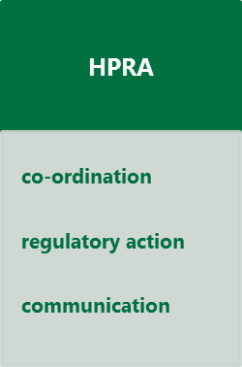The HPRA’s role in medicine shortages is to co-ordinate the response to a shortage across stakeholders so that the impact is mitigated as much as possible. The HPRA has a number of regulatory tools and strategies available to assist stakeholders in preventing or minimising the impact of a medicine shortage (for example use of a batch specific request or the exempt medicinal product scheme). The HPRA prioritises regulatory actions to reduce the impact of shortages. Regulatory discretion may be employed to mitigate any significant risk to patients. The HPRA provides information on particular medicine shortages through its website and via other media where appropriate.

The HPRA’s regulatory remit does not extend to certain areas, for example pricing, sourcing medicines, clinical practice, nor can it require a company to produce a medicine or determine the supply route by which to distribute it as long as it satisfies good distribution practice requirements.

* 1. Healthcare professionals

Healthcare professionals (e.g. prescribers, pharmacists and nurses) use their professional expertise to identify alternative medicines or therapies for their patients if a medicine is unavailable due to a shortage. Healthcare professionals can be involved in clinical guidance on appropriate treatment alternatives during a medicine shortage. Healthcare professionals also play an important role in promoting appropriate use and the ethical and fair distribution of medicines to meet the needs of patients. For example, in some cases, the action of stockpiling has been reported to precipitate a shortage.

* 1. Patient representative groups

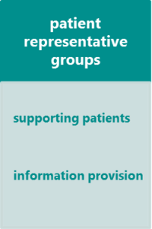

Patients need timely access to medicines. In the case of some medicine shortages, patient representative groups, particularly disease-specific groups, may need to be involved in supporting patients with information on the shortage and alternative medicines. Patient representative groups can also provide information to other stakeholders on the impact of a shortage. Individual patients may also report medicine shortage, once aspects such as logistic issues have been ruled out.

* 1. Department of Health

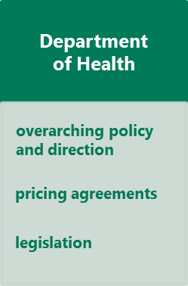The Department of Health has an overarching policy and direction role to achieve a sustainable and accountable health system and to promote and protect the health of patients in the country. It provides leadership for the health sector to improve health outcomes. This includes the development and review of legislation, representing stakeholder interests in an international context and contributing to initiatives to mitigate the risk and disruption caused by medicine shortages.

The Department of Health also has oversight of the HSE and HPRA, and supports agencies under its aegis to deliver their statutory functions. It negotiates agreements with marketing authorisation holders, along with the HSE, in relation to pricing and supply of medicines.

1. Principles of the framework

The framework for dealing with a medicine shortage is based on a commitment by all key stakeholders to the communication and management of medicine shortages according to the following principles:

* The health and safety of patients is the top priority in all medicine shortage communication and responses.
* Medicine shortages are a multi-stakeholder responsibility, requiring the co-ordinated involvement of all stakeholders across the supply chain.
* Early notification of a potential or actual medicine shortage is critical to helping to prevent or mitigate a shortage.
* The assessment of and response to medicine shortages may involve the co-ordination of advice and activities by a range of stakeholders and experts.
* Impact assessments, notifications and updates are reliable, timely, consistent and comprehensive.
* A co-ordinated response and communication of appropriate information are essential in handling shortages.
* The nature of a shortage is varied and therefore responses to medicine shortages will be on a case-by-case basis and may require flexibility.
* Not all potential shortages will ultimately result in actual shortages.

1. Medicine shortages framework

Once a potential shortage has been identified, it is important to establish the nature of the shortage, the potential impact on patients and to identify mitigation measures. The sections below provide details for stakeholders on these steps.

* 1. Notification or report of a medicine shortage

All stakeholders may report a possible shortage. Before reporting a possible shortage to the HPRA, stakeholders should have exhausted other possible reasons for supply delays. The initial communication of an actual or potential shortage to the HPRA is confidential. This is to allow potentially sensitive information relating to the shortage, including possible solutions, to be discussed between the stakeholder and the HPRA. However, it may be necessary for the HPRA to communicate with other stakeholders and the public as appropriate in particular cases.

***How and when to notify or report a shortage***

For the purposes of clarity, a notification of a shortage comes from the MAH whereas a report of a possible shortage comes from all other stakeholders. Where the notification comes from an MAH or their representative, the notification form should be used. The notification form is common to the HSE and the HPRA and can be submitted to the two agencies simultaneously. The notification form also provides for a proposal from the MAH to handle a shortage, which may range from minimal activity in the case of low impact shortages, to a detailed management plan for high impact shortages. A reporting form for other stakeholders has been developed and is available from [www.hpra.ie](http://www.hpra.ie).

Please see table 1 for a summary of when to notify and the information required. All information relating to potential and actual shortages, regardless of which stakeholder contacts the HPRA, should be sent to [shortages@hpra.ie](mailto:shortages@hpra.ie).

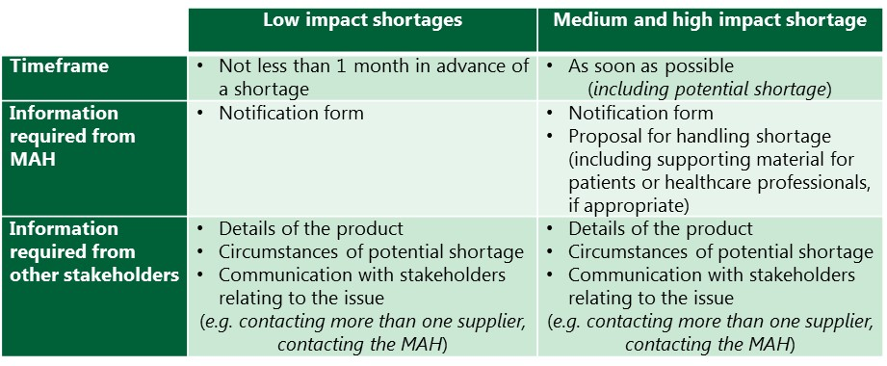

**Table 1:** How and when to notify/report a shortage

* 1. Impact assessment

The method described below is used by the HPRA and can also be used by stakeholders to assist them in determining the impact of the actual or potential shortage. The impact assessment combines two main considerations:

* the availability of therapeutic alternatives and
* the expected impact on patients.

***Therapeutic alternatives***

The categories of therapeutic alternatives and associated descriptions are provided in **table 2**. These are illustrative and provide guidance when categorising the nature of the therapeutic alternative.

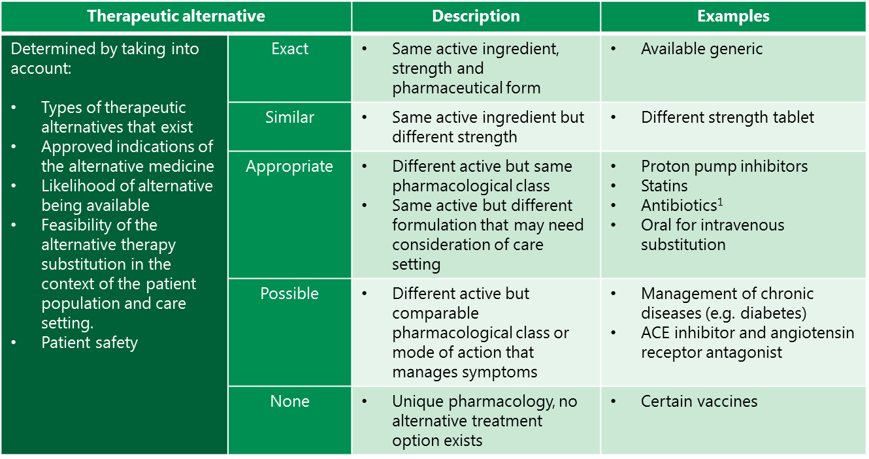

**Table 2:** Description of therapeutic alternative categories[1]

***Impact on patients***

The categories and associated examples in relation to the impact of a shortage on patients are described in **table 3**. As with the categorisation of therapeutic alternatives, these are illustrative.

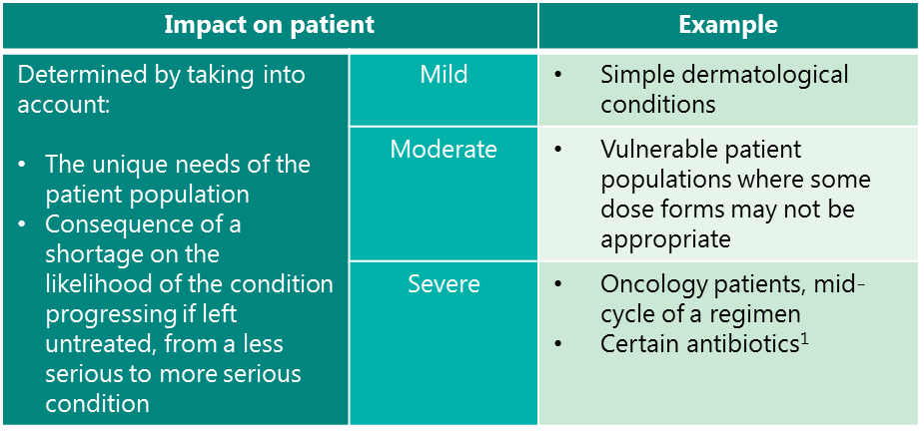

**Table 3:** Description of the impact categories1

***Determination of impact level***

Once the availability of therapeutic alternatives and expected impact on patients are determined, the impact level of the shortage is identified using the matrix described in **table 4**.

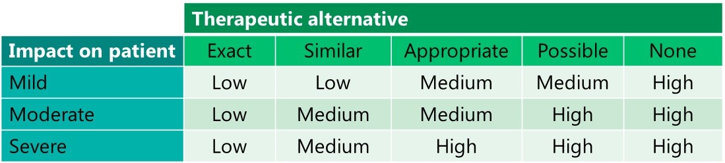

**Table 4:** Impact levels

The impact assessment classifies medicine shortages into three types: low, medium and high impact shortage.

***Low impact shortages***

The potential response to a low impact shortage is based on the assumption that healthcare professionals will be able to manage the situation through professional expertise and access to information on the availability of the product.

*Example****:*** *a shortage of atorvastatin 20mg film-coated tablet where another generic product is readily available and can be substituted with little effect on the doctor, pharmacist and patient.*

***Medium impact shortages***

The potential response to a medium impact shortage is based on the assumption that healthcare professionals are reasonably able to manage the situation if they have access to timely information about supply arrangements.

*Example:* *a shortage of a proton pump inhibitor where a doctor would need to change the prescription to another medicine.*

***High impact shortage***

The required response is based on the assumption that healthcare professionals require highly specific and urgent information on the nature and anticipated duration of the shortage as well as details about supply arrangements and clinical guidance on substitute medicines or therapeutic alternatives.

*Example:* *a batch failure of a heparin-based product. This switch to a therapeutic alternative is complex and the post-surgical population group could potentially experience life-threatening impacts if this medicine was not available.*

Although MAHs are not required to use the above method as part of the impact assessment (industry generated papers detailing risk assessments for shortages are available, for example), the principles described in relation to what constitutes a low, medium or high impact should be used in order to harmonise the understanding of the impact of a shortage. The impact of the shortage can also inform a proportionate mitigation response from the MAH.

* 1. Communication

Stakeholders, particularly healthcare professionals and patients, are better placed to address a shortage if there is appropriate communication. For example, timely communication of actual or potential shortages to healthcare professionals can facilitate changes to prescriptions, give time to source and introduce alternative therapies and reduce the impact on healthcare systems. The timing of the communication depends on the dynamics of the particular shortage. Not all potential shortages result in an actual shortage and therefore, communication of potential shortages may not be required.

Shortages will be communicated via the HPRA website, particularly medium and high impact shortages. Low impact shortages will usually not be published as many of these cases can be resolved by the pharmacist as part of good professional practice. Stakeholders can register on the HPRA website for e-mail alerts in relation to shortages. The information that will be published on the HPRA website includes:

* The name of the medicinal product
* The active ingredient
* The marketing authorisation number
* The reason for the shortage
* The expected return date
* Company details for further information
* Additional information as needed (e.g. communication from the MAH)

High impact shortages may involve a range of stakeholders working together, sharing expertise and information, in which case additional communication media or additional communication by the HPRA, HSE or MAH may be used.

Once normal supply has resumed and confirmation is sent to the HPRA, either by the MAH or their representative (such as its nominated primary wholesaler), the HPRA then updates the website to reflect the status of the shortage situation and closes the shortages case.

1. Preventative Strategies

In addition to the framework for handling shortages, another feature of the multi-stakeholder approach is that the HPRA and other stakeholders will develop and implement preventative strategies to reduce the likelihood of shortages occurring in the first instance. In many instances, these will be aimed at the underlying causes of shortages and would ensure that shortage prevention is actively considered as part of the life cycle management of the medicine.

Illustrative examples of preventative strategies include stakeholder-developed strategies and principles such as:

* Systems-based tools to assist stakeholders assess their preparedness for preventing or managing a shortage. They include recommendations for developing a corporate quality culture, a robust quality system, metrics, business continuity planning and optimal communication as these aspects relate to shortages.
* Product level risk-based tools to help pre-emptively identify potential risks to a medicine’s supply. These include a medicine shortage risk register and a medicine shortage prevention and response plan.

1. Concluding remarks

As alluded to in the first Section, the purpose of the document is to outline a framework for stakeholders to reduce the impact of shortages on patients. The framework is part of an iterative process for the development of appropriate responses and efforts to mitigate against the risk of shortages. Whilst the HPRA has a co-ordinating function, the importance of all stakeholders contributing to the management of shortages is essential to addressing the issue of medicine shortages in Ireland.

1. Reference to antibiotic use is dependent on the sensitivity of the infective organism