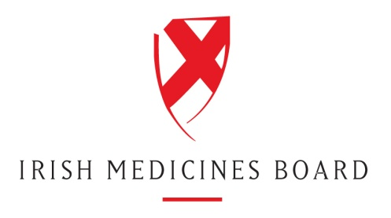

Programme for the IMB Vet Info Day, 6 October 2011

Venue: Radisson Blu Hotel, Dublin Airport
Time: Registration will take place from 8.50 am to 9.15 am.

9.15 | Welcome and Programme Outline - J.G. Beechinor, IMB
9.25 – 10.45 | Session 1 – Chaired by David Murphy, IMB  IMB Drivers and performance  Strategic objectives and key achievements in recent times  Departmental performance and KPIs
11.00 – 11.30  11.30 – 13.00  13.00 – 14.20  14.20  14.25 – 14.55  14.55 – 15.25  15.25 – 15.55  15.55 – 16.15  16.15 – 16.30 | Receipts and Validation  Overview of process and recent experiences  Experience with electronic submissions  Experiences with variations  Questions and answer on session 1 topics  Coffee  Session 2 – Chaired by Mary O’Grady, IMB  Veterinary Medicines Department updates  Joint labelling with the UK  MRP and DCP  Referrals  Pharmacovigilance  Experiences with borderline products  Questions and answer on session 2 topics  Lunch  Session 3 The Veterinary Legislative Review – what it is; what the process will be; what it is expected to mean for you - Chaired by Mr. Pat Brangan, Department of Agriculture, Food and the Marine  Keynote 1 Industry perspectives on the review of the veterinary legislation – Mr. Rick Clayton, IFAH-Europe  Keynote 2 The review process and the Irish Presidency of the EU Council - Department of Agriculture speaker , Mr. Philip Kirwan, Dept of Agriculture, Food and the Marine  Keynote 3 How the process might affect the regulatory environment in Ireland – J.G. Beechinor, IMB  Questions and answer session  Close

